KARUPPARAYA YUVARAJA.S
S/O Mr.S.M.Selvaraj,
3,NGGO Colony 2nd street,
Surampatti (P.O),
Erode DT,
Tamilnadu.
Pin 638009.
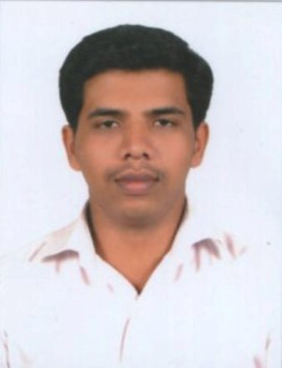

Email ID : yssky4@gmail.com
Mobile No : +91 96291 26881

CAREER OBJECTIVE
To be an integral part of a motivated and high-energetic team in a world class organization like yours and aspire to grow with the organization.
EDUCATIONAL QUALIFICATION
Qualification | Name of the College | Year of Passing | Percentage / Percentile
M.E (Computer Science and Engineering) | SNS College of Engineering, Coimbatore. | 2012 – 2014 | 78%
Master of Computer Application | Sri Krishna College of Technology, Coimbatore. | 2009 – 2012 | 81%
Bachelor of Computer Science | Nandha Arts And Science College, Erode. | 2006 – 2009 | 74%
Higher Secondary | Nandhi Matriculation Higher Secondary School, Erode. | 2005 – 2006 | 67%
SSLC | Nandhi Matriculation Higher Secondary School, Erode. | 2003 – 2004 | 57%

COMPUTER SKILLS
Language : C, C++, Core Java.
WebTechnologies : Basic HTML ,Angular JS.
Software : MS Office, Visual Studio 2008
Databases : MS SQL 2005, Microsoft Access.
Systems : Windows (98, 2000, XP, Vista,w7)
AREAS OF INTEREST
- Core Java.
ACADEMIC PROJECTS
PG Project 1
Back-Bone Assisted Hop Greedy Routing Using Clustering Approach In Vanet
- Hybrid Approach using cluster based routing to provide a routing algorithm which works on a hybrid scenario.
- It will help the node for transmitting packets even in a network with low vehicle density
- cluster head backbone nodes play a key role in providing connectivity status around intersections
- The benefits of the proposed strategies are high packet delivery and shorter end to end delay.
PG Project 2
Title : Student Web Portal

Front end : ASP.NET

Back end : SQL Server 2005

Description : This project aims to maintain the informations needed for student
academic studies.

EXTRA- CURRICULAR ACTIVITIES
- Secured First Prize in Marketing Event conducted by Hindustan College of Engineering Coimbatore (2010).
- Secured First Prize in Marketing Event conducted by Hindustan College of Engineering Coimbatore (2011).
- Secured Second Prize in Quiz Event conducted by EBET Educational Trust,Tirupur.

RESPONSIBILITIES UNDERTAKEN

- Placement Co-ordinator of MCA department
- Co-ordinator for Debugging event in CATENA-10

PERSONAL SKILLS
- Ready to share responsibilities and knowledge.
- Ability to work well both independently and in a team environment.
- Goal oriented and hard working, determinant to succeed.

PERSONAL DETAILS
Date of Birth : 10th DECEMBER 1988
Father's Name : SELVARAJ.S.M
Mother's Name : RADHA JAYALAKSHMI.S
Nationality : INDIAN
Mother Tongue : TAMIL
Hobbies & Interest : Playing cricket,Listening Music.

REFERENCES
1. Dr.V.VenkatesaKumar, Assistant Professor, Department of Computer Science and Engineering, Anna University Regional Center, Coimbatore, Ph: 09600930799.

DECLARATION
I hereby assure you that the information furnished above is true to the best of my knowledge.
Place :
Date : Karupparaya Yuvaraja.S

